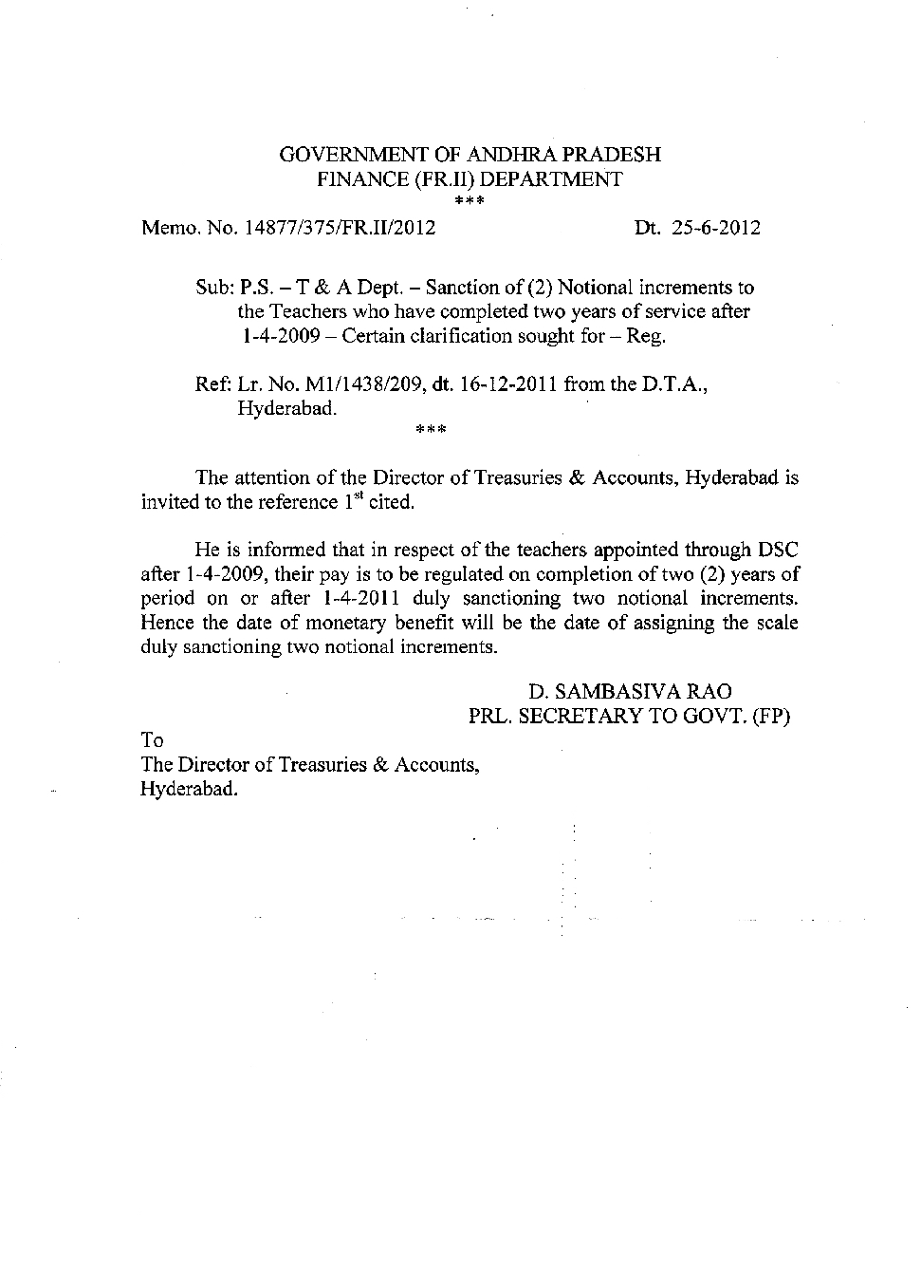 | www.apteachers.in

UTF A.P.UNITED TEACHERS' FEDERATION

Ph No: 27677242; Fax No: 27650366;email: aputf2000@yahoo.com

27.06.2012

PDF to Word

